
phgy311
lecture #: | date: | professor:
6 | Sept. 18 | Dr. Cooper
7 | Sept. 20 | Dr. Cooper
announcements:
- PULS Pizza and Beer is Wednesday Sept. 27 from 12-3pm at Gert’s so come party it up after our first quiz!!
- I still need writers for 311, if you’re interested email phgy311ntcs@gmail.com

Edited by: Steph Rolin
set #2
CORRECTION:
In Lecture 5, it is stated that tao is the key to temporal summation. It is not! R(in) is the key to temporal summation. We know large cells integrate, and small cells are relay cells. That’s dependent on their resistance, not their time constant. Tao has some role, but don’t focus on that.
I have highlighted the incorrect parts in red on the lecture 5 ntc.

September 18, 2006
PHGY 311: Lecture #6, Dr. Cooper
Writer: Anastasia Coutinho

REVIEW: PASSIVE PROPERTIES OF THE CELL/TEMPORAL SUMMATION
NEW MATERIAL: SPATIAL SUMMATION

- Remember, we are reviewing how to determine the change in potential, how much change is taking place, and what causes an AP.
  - This is determined by:
    - Resting membrane resistance
    - Membrane capacity
    - Axial resistance
  - Which determine:
    - Time course
    - Amplitude
    - Depolarization extent
    - Speed of conduction

- The two most important passive electrical properties are:
  - 1. Resting ion channels [combined to give R_{in}]
  - 2. Membrane capacitance
- Together these affect temporal and spatial integration of synaptic inputs
  - Each nerve cell receives synaptic inputs at different times and places
  - Passive properties of the neuron govern integration of these signals
    - Integration is what determines if an action potential is produced or not

- The membrane can be equilibrated to an electrical circuit:
- Note: see more detailed descriptions below
  - Ion Channels: the ion channels represent resistors
  - Membrane: the distribution of charge represents capacitors
  - Na⁺/K⁺pump: the recharging of the circuit represents current generators
    - Note: the direction of current flow out of each generator is different [due to the opposing flow of Na⁺ and K⁺]
  - For each ion, its own equilibrium potential would be equal to the battery supplying current to that resistor
    - Note: the direction of the battery for K⁺ and Cl⁻ compared to Na⁺
  - Current flow is what connects the circuit 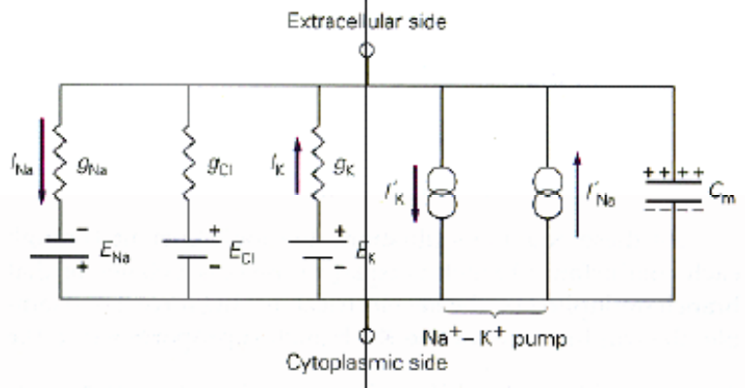

- Each resistor for the individual ions can be summed to equal the input resistance, R_{in}, which determines the amplitude of the change in membrane potential in response to a steady current
- Similarly, we can sum up all the individual batteries to equal the membrane potential.
  - See simplified circuit below.

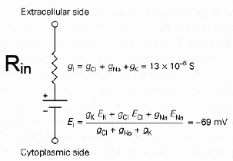
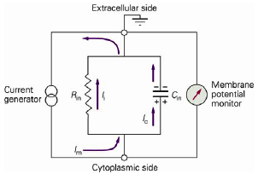
RESISTORS
- The sum of all the resting membrane ion channels equals total input resistance, R_{in} [depicted above]
  - This is important for the amplitude of the change in membrane potential during a synapse [i.e. the amount of depolarization for a given current depends on R_{in}]
    - This can be calculated using ∆V = I*R_{in} [Ohm’s law]
      - Note: remember to check your units
      - Note: Ohm’s law is only valid for when there is no concentration gradient [i.e. no force applied on the membrane]

- This can be depicted experimentally:
  - 1. Inject current for a discrete amount of time [graph A₁]
  - 2. Measure the change in membrane potential
  - 3. At every current interval, examine the output
  - 4. Superimpose each output to get graphs below
  - Note: before we injected the current, all channels that would result in producing an action potential [i.e. voltage-gated] were removed to determine the impact of passive properties only
    - If they were present, a curved relationship would be shown rather than a linear function
- It can be seen that voltage, V_{m,} and current, I, have a linear relationship [graph B]

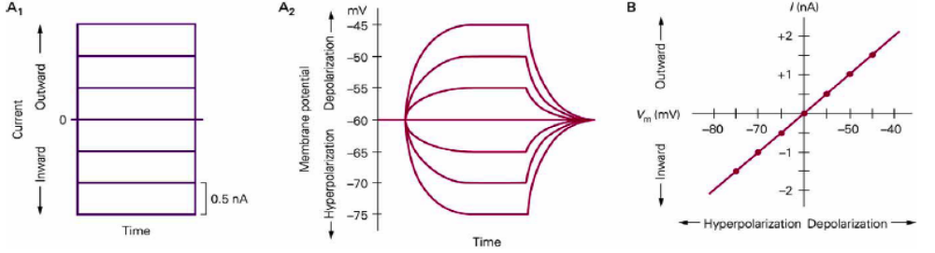

CAPACITORS
- Capacitance is the ability of the membrane to store charge.
  - It depends on the surface area of the cell.
- Note the exponential time course of membrane potential growth and decay [graph A₂]
  - This is because it takes time for the membrane to be fully charged and then decay, whereas turning on and off the current is instantaneous.
    - The amount of time it takes for this to occur is governed by the time constant.
- This is how a capacitor would store charge [see relationship between current and storing charge in the graph below]
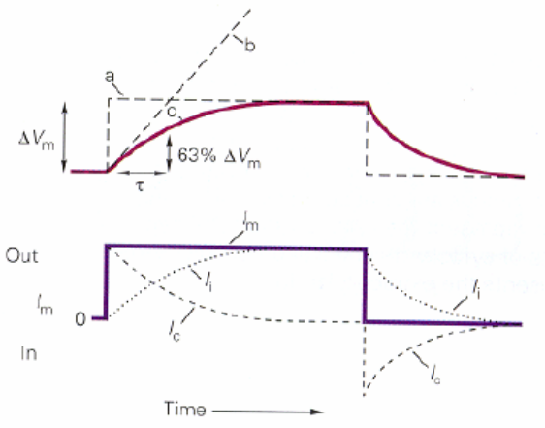

TEMPORAL INTEGRATION
- You can determine the relationship of V_{m} and I based on values of C and R_{in} based on the following equation:
  - ∆V_{m}(t) = V_{f}(1 – e^{-t/τ})
    - Where, τ = C_{m}R_{in} and V_{f} = I_{m}R_{in}

- τ = Time constant, which measures the time it takes to charge the capacitor

  - Initially all current moves through the capacitor [large exponential curve up] at which point it begins to flow through the resistor [which decreases flow]
    - If you increase the resistance, the slower your rise will be

- When I_{m} is turned off [ion flow ceases], V_{m} will decay to rest by the equation:
  - ∆V_{m}(t) = V_{P}e^{-t/ τ}
    - Note: when t= τ, the voltage is 2/3 of the rise; Similarly, during decay, when t= τ, the voltage is 2/3 of the peak value

- During the current flow, the circuit wants to achieve a maximum resistance equal to R_{in}, but cannot due to the short time period the current is actually active for [≈1ms] and therefore begins to decrease

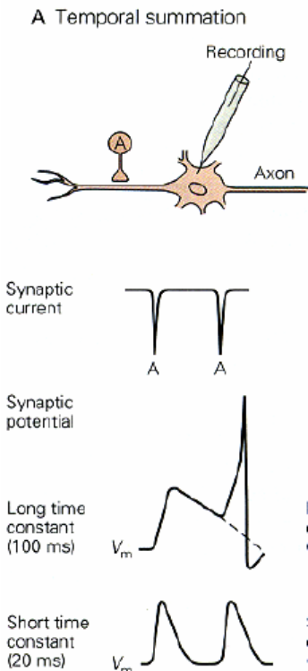
- Note: See examples of membrane potential growth and decay in slides
  - During examples, be aware of the difference between R_{in} and R_{in(syn)}
    - R_{in} is while the membrane is at rest and R_{in(syn)} is the peak of resistance during a synapse
  - Also note that during decay, the time is taken from the peak of the change in membrane potential rather than the start of current injection

- The exponential rate of decay is crucial for temporal summations of EPSPs to each the threshold, to be able to fire an action potential
  - If the time constant is longer the more time the neuron has to summate
  - Problems involving summation would use the same formulas, but the voltage value at the point of the new EPSP would have to be added to the initial voltage [i.e. V_{o} would not be the base value]

- Note that exponential decay also depends on other factors.
  - A synapse that opens up chloride channels would cause the decay to occur faster.
  - A synapse that closes potassium channels slows the decay.

SPATIAL SUMMATION
- Spatial summation is also important in governing APs.
- A synapse can land anywhere on a dendrite
  - Location will have a massive effect on the extend of depolarization/change in membrane potential
- Why?
  - Dendrites are leaky, due to resting ion channels.
    - Leakiness will cause the attenuation of the signal, due to dissipation of charge
    - Therefore, the total current that reaches the soma will be decreased, but still needs to be above threshold to generate an action potential
    - Amount of leakiness can be determined experimentally [follows an exponential decay function]
  - See different types of dendrites attached to somas in slides
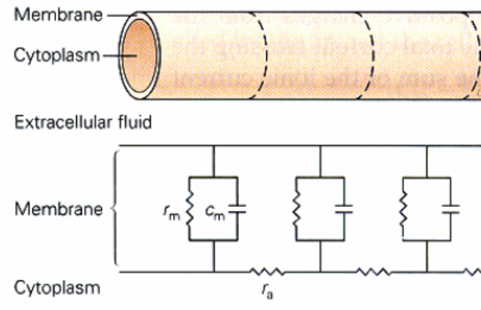
- To understand leakiness, we need to again examine the distribution of a circuit within the membrane:
  - The dendrite can be broken down into units, which can be represented by a capacitor and resistor, which are connected within the axon, represented as a resistor
    - Each dendritic unit is connected in parallel to each other

- The split of current [some through the axial resistor and some not] is analogous to how current is dissipated within the membrane: current can either flow along or through the membrane.
  - Current will follow the path of least resistance:
    - In this case, the axial cytoplasm provides resistance to current flow, which decreases amplitude of membrane potential change
    - In addition, resistance increases with distance from the site of injection, which leads to further loss of charge

- Leaking follows the function: ∆V_{x}(t) = V_{o}e^{-t/λ}
  - An exponential decay function based on a space constant
  - Note: When x = lambda, ∆V_{x} = 0.37V_{o}

- Λ = space constant, which is dependent on resting ion channels and the resistance of the cytoplasm, is the distance along the dendrite to the site where V_{m} has decayed to 1/3 of its initial value
  - Measures the efficiency of the passive conduction along the length of the dendrite
  - Equal to the ratio of axial and membrane resistances:
    - Λ= [r_{m}/r_{a}]^{½}
      - r_{a} = p/πr²
      - r_{m} = R_{m}/2πr
    - Λ = [R_{m}πr²/2πrp]^{½}
    - Λ = [R_{m}r/2p]^{½}
    - Note: axial resistance is dependent on properties of the axon [i.e. intrinsic resistance, cross-sectional area]; R_{m} versus R_{in}: relatively the same, dependent on the number of open channels, but measured differently; p is the resistivity of the cytoplasm

  - Therefore, the space constant is dependent on the diameter of the cell
    - The larger the diameter, the longer the length constant, the greater the spread, the faster the action potential propagation

  - Length constant influences:
    - Spatial summation
    - Propagation/Attenuation
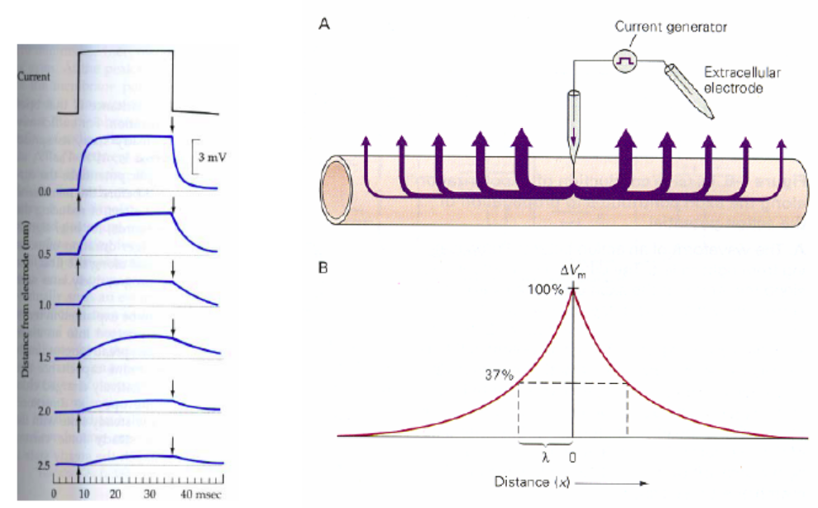
The relationship between current, decreasing amplitude of membrane potential and distance

- Do examples in the slides, noting what happens as the diameter of the axon is changed, the density of the ion channels, etc

SUMMARY
- Everything up to now only accounts for passive contribution to the cell
- Temporal Summation depends on the time constant whereas spatial summation depends on the length constant
  - For our purposes right now, disregard the voltage-gated ion channels

  - ∆V_{m}(t) = V_{f}(1 – e^{-t/τ})
    - Where, τ = C_{m}R_{in} and V_{f} = I_{m}R_{in}
  - ∆V_{x}(t) = V_{o}e^{-t/λ}
    - Λ = [R_{m}r/2p]^{½}

- The consequence of summation: for dendrites to integrate synaptic inputs to depolarize the axon hillock to threshold
  - Note that passive inputs are not always only the case for depolarization in recent experiments. One must factor in voltage-gated ion channels, which can be activated to help propagate/integrate [this will be discussed next lecture]

- Conveyance of an action potential:
  - 1. Depolarization
  - 2. Propagation
  - 3. Signal conveyed
  - 4. Summation
    - Complex integration to form action potential
  - Recall: Different types of cells generate different action potential bursts. This is the key to the neural code.
    - This is due to the different roles/different voltage-gated channels
    - To determine experimentally: compared normal firing with firing at hyperpolarization [see graphs below]
      - A: during hyperpolarization, the same train is triggered, but without the high frequency burst at the onset. This burst seems to be important for neural coding
      - B: at RMP there seems to be little effect, but during hyperpolarization, there is a slow depolarization, burst of action potentials, and then repolarization
      - C: in the brain, spontaneous, rhythmic bursts
        - Similar to the SA node in the heart
      - D: signal fires ones and quickly adapts to the stimulus
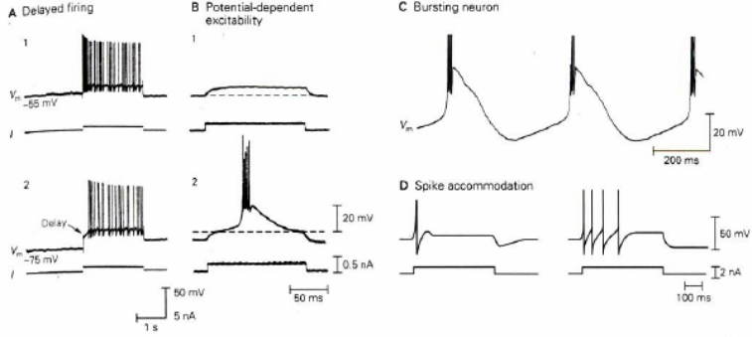

VOLTAGE GATING – to be continued next class
- However, there are voltage-gated channels in the membrane, which need to be understood to determine how an action potential is made
- Depolarization is a positive feedback loop.
  - g_{Na} increases I_{Na}, which increases depolarization, which increases g_{Na…}
- Depolarization is a result mainly of the activation of voltage-gated Na⁺ channels, which undergo conformation changes in response to an increase in membrane potential
  - This will be discussed over the next couple of weeks…

WHAT YOU SHOULD KNOW BY NOW
- Ionic currents [I_{x}]
- Conductance [g_{x}]
- Resting potential [V_{m}]
- Membrane capacitance [C_{m}]
  - For biological membranes: 1µF/cm²
- Capacity Current
- Total membrane current
- Temporal Summation and time constant
- Spatial Summation and length constant

September 20. 2006
PHGY 311: Lecture #7, Dr. Cooper
Writer: Renata Sasson

REVIEW
- So far, we’ve only seen ion channels that are open at rest.
  - Resting membrane potential is established by the ratio of the conductances of the various ions as well as the driving force.
- Membrane potential is stored across the membrane capacitor.
  - In order to change the membrane potential you must change the charge on the membrane capacitor.
- We talked about how open ion channels and the membrane capacitor can influence any synaptic currents.
  - Spatial and temporal summation.
- There are only a handful of principles you must understand in order to understand all that we’ve done so far.
  - Important to understand this part of the course because these concepts will be built upon later in the course.
- A good way to study for the quiz is to form study groups and make up questions to make sure you really understand what’s going on in the examples and that you understand the concepts from all angles.

VOLTAGE-GATED ION CHANNELS
- Stimulus for voltage-gated ion channels to open is a change in membrane potential.
  - These channels are the key to eliciting an action potential.
  - The complex way that different nerve cells can fire is really a consequence of different voltage-gated ion channels that come into play at different times or at different voltages. 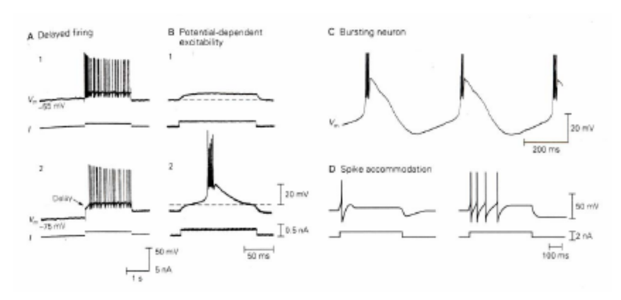
- There are hundreds of different types of voltage-gated channels that all respond differently to changes in voltages.
  - As long as you understand how the voltage gated Na⁺ channels and voltage gated K⁺ channels work, you’ll be able to understand any other voltage gated ion channel.

DURING AN AP
- Depolarization first opens Na⁺ channels, thus increasing gNa.
- Increased Na⁺ flow into the cell causes membrane to depolarize further.
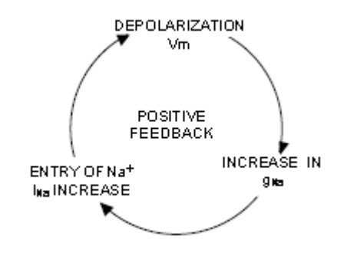
  - Positive feedback (as Na⁺ come in, they open up more Na⁺ channels)
    - That’s what drives the first part of the action potential (to the peak)
    - Action potential reaches peak in less than a millisecond!
  - Probability of a single Na⁺ channel opening is a function of membrane voltage.
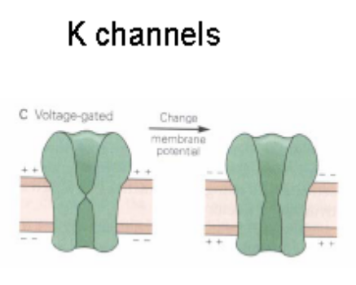
    - For a single channel, the more you depolarize, the more likely it is that that channel is going to open.
- Na⁺ channels open quicker than K⁺ channels and inactivate quicker as well.
  - K⁺ channels are still open long after Na+ channels close.

- Example: A cell at rest has E_{K}= -90mV, E_{Na}= +60 mV, and gNa/gK = 1/10. The resting potential, Vm= -76mV. If gNa increases 50 times from rest at the peak of the action potential, what is Vm at the peak?
  - At the peak (gNa/gK) = 5
  - Vm= (gNa/gK)E_{Na}+ E_{K}
(gNa/gK) + 1
  - Vm= (5)(60) + (-90)
(5) + 1
  - Vm= + 35mV
  - Conclusion: We can estimate how high the peak of the action potential is going to be by knowing how much the conductance changes. A 50 fold increase in Na⁺ conductance is enough to drive Vm to the peak of the action potential.
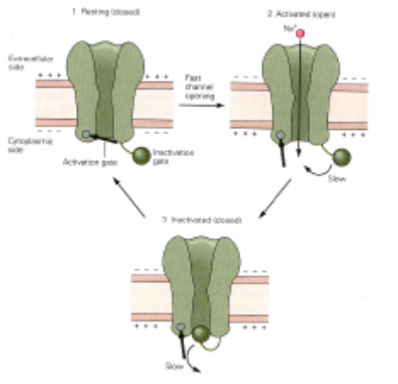
- Note that the gNa⁺/gK⁺ ratio changes throughout the course of the action potential
- Refractory period is the period right after the action potential when Na⁺ channels have been inactivated but K⁺ channels are still open.
  - It is very difficult to elicit another action potential during this time.
  - gNa⁺/gK⁺ ratio is less than it was at rest.
    - .05 instead of .1
- Inactivation of Na⁺ channels helps to repolarize the membrane (see diagram at right, the bottom channel is inactivated).
- Threshold is defined as the amount of depolarization needed in order to trigger an action potential
  - Very important to note that threshold is NOT a constant value. In other words, the amount of depolarization that you need varies depending on the state of the cell.
    - For example, during the relative refractory period, the threshold has increased. An inhibitory synapse could also have an effect.
    - This is the key to excitability.

THE VOLTAGE CLAMP
- Used to study the effect of voltage on the channels.
  - Crucial in order to understand how ion channels work.
- The voltage clamp is a technique that allows us to move the membrane potential to different values and to be able to study how the ion channels react.
- Hodgkin, Huxley and Katz set down the fundamentals of how to measure voltage-gated ion channels.
  - Conductance increases with increasing membrane potential.
  - Measured using voltage clamp technique.
- Conductance is a function of membrane potential and time. Below is a graph of what one measures with the voltage clamp:
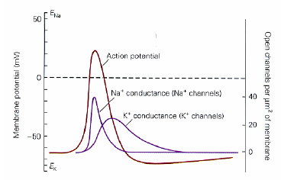
- Ideally, what one would to do study voltage-gated ion channels is to move the membrane to a given potential and see how the channels respond to that.
  - Problem: as soon as you begin to depolarize the membrane, it can act autonomously and fire an action potential.
    - Need a way to keep the membrane potential constant and to counteract the positive feedback loop.
- The voltage clamp keeps the membrane potential constant by injecting current into the cell.
  - The injected current is opposite that of the cell and thus cancels out any depolarizations with a hyperpolarizing (negative) current.
    - Maintains charge on the membrane capacitors constant!
- As soon as the membrane potential starts getting into the positive feedback cycle, this is detected and a negative current is delivered to counteract it.
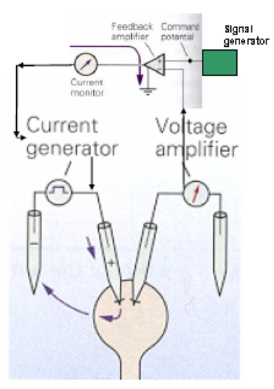
  - No human is able to react fast enough to deliver the current before the action potential can occur, as this happens on the order of milliseconds.
- The voltage clamp is an electronic means to control membrane potential.
  - You can simply set the voltage clamp to the desired voltage you want to observe and it will then detect and counteract any deviations from that voltage automatically.
  - To the right is a diagram of the setup of the apparatus.
- The membrane wants to change its potential, so it’s opening the necessary channels, but the voltage clamp is injecting an equal and opposite current to keep the membrane potential constant.
  - Note that this means that the injected current is exactly equal and opposite to the ion currents flowing through the ion channels.
    - Therefore we can measure what the cell does at a particular voltage simply by taking the negative of the injected current.
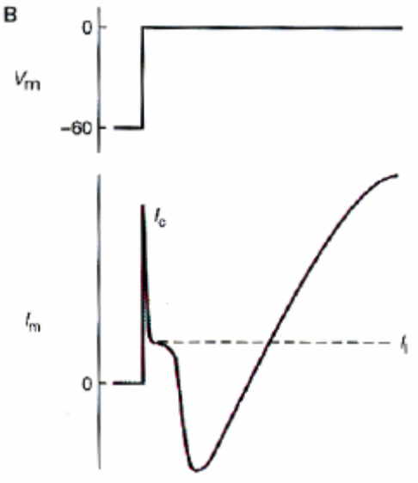
- Example: What would you expect to see( in terms of ion currents) in a voltage clamp experiment if you change the membrane potential from -60mV to 0mV?(top graph)
  - Inward current, followed by an outward current (bottom graph)
  - Graph (bottom) depicts the behavior of currents passing through all types of ion channels in the cell during the experiment.
  - I_{c} = capacity artifact or capacity current
    - I_{c}= Cm* dV/dt
    - Related to rapidly changing the charge on the capacitor. Tells us nothing about ion channels and not important for our purposes.
  - I_{m} = ionic current passing through membrane.
- How do we separate out the currents we are measuring?
  - Pharmacological tools
    - Tetrodotoxin (TTX), Saxitoxin
      - Na⁺ channel blocker
      - Very high affinity for ion channels
      - From fish
    - Lidocane, xylocane
      - Na⁺ channel blocker
      - Lower affinity for ion channels
      - Local anesthetics

    - TEA ( Tetryethylammonium)
      - K⁺ channel blocker
      - Lower affinity for ion channels
  - Administer TEA to measure just the Na⁺ current, I_{Na}= G_{Na}* (Vm-E_{Na})
    - Below at left
  - Administer TTX to measure just the K⁺ current, I_{K} = G_{K}* (Vm-E_{K})
    - Below at right

